User Manual

1. Set up the program. The commands are shown in the following picture

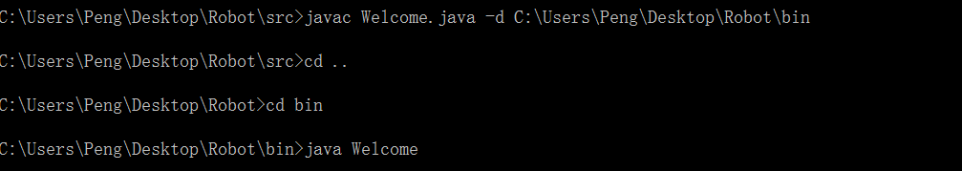

1. Enter the program. The first page is the welcome page. Pressing it you will enter the user interface.

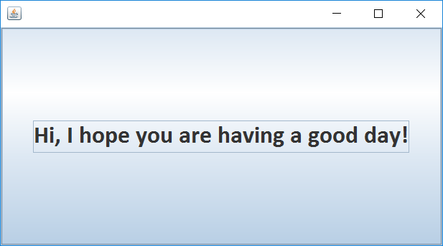

1. The user interface is shown as follow you can fill the number you have chosen into the blank field and press the confirm button to submit your choice. If you want to leave our restaurant, just pressing the pay button.

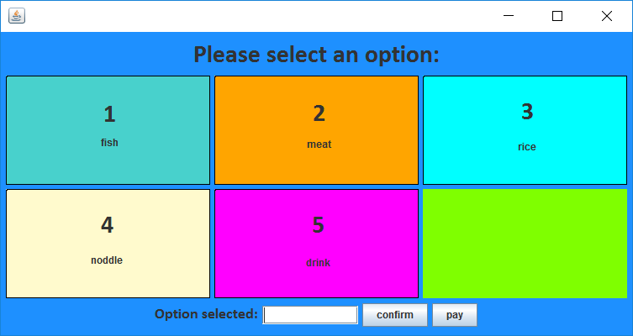

1. If you have already confirmed type of food you want, you will enter the order page. In this page you can choose dish you want to eat. Just fill the number of dishes into the blank filed and press the confirm order button. If you do not want to order again, you can press the button of return to main menu

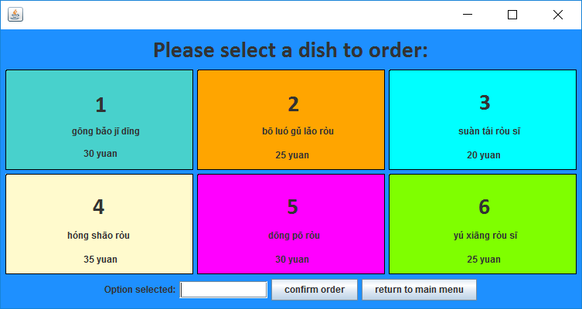

1. If the dish you selected sold out, the order page will give prompt information.

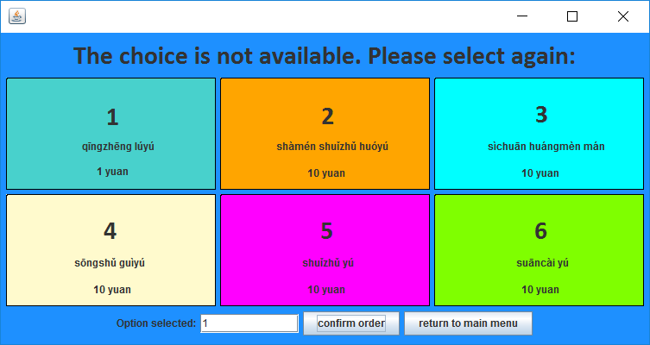

1. If you have ordered your dish, the program will ask you to confirm your option.

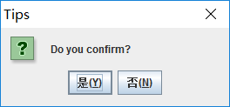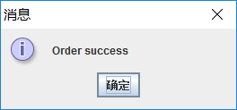

1. When the dish sent to you, the program will tell you a joke. If you don’t like you can just press the back button.

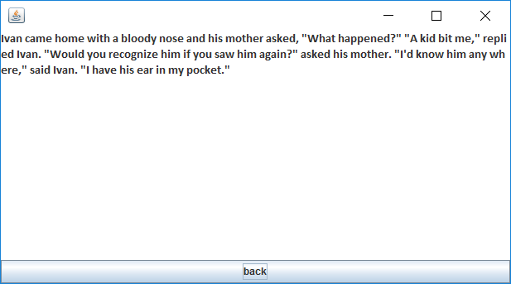

1. When you want to leave and press the pay button, you will enter to the payment page. It will show the money you should pay.

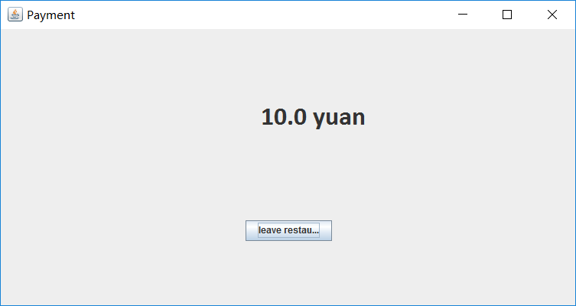

1. Press the leave restaurant, the program will say farewell to you. Press the leave restaurant again, you will exit the program.

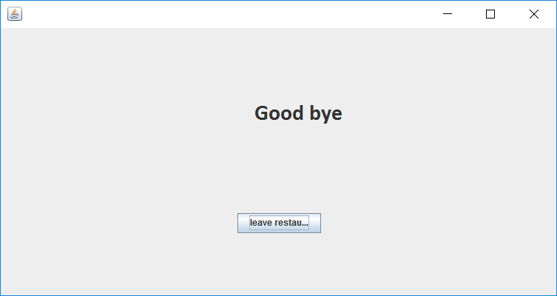

1. If you don’t have any operation within 30s, the program will enter the inactive page. Pressing the wake button can awake it.

